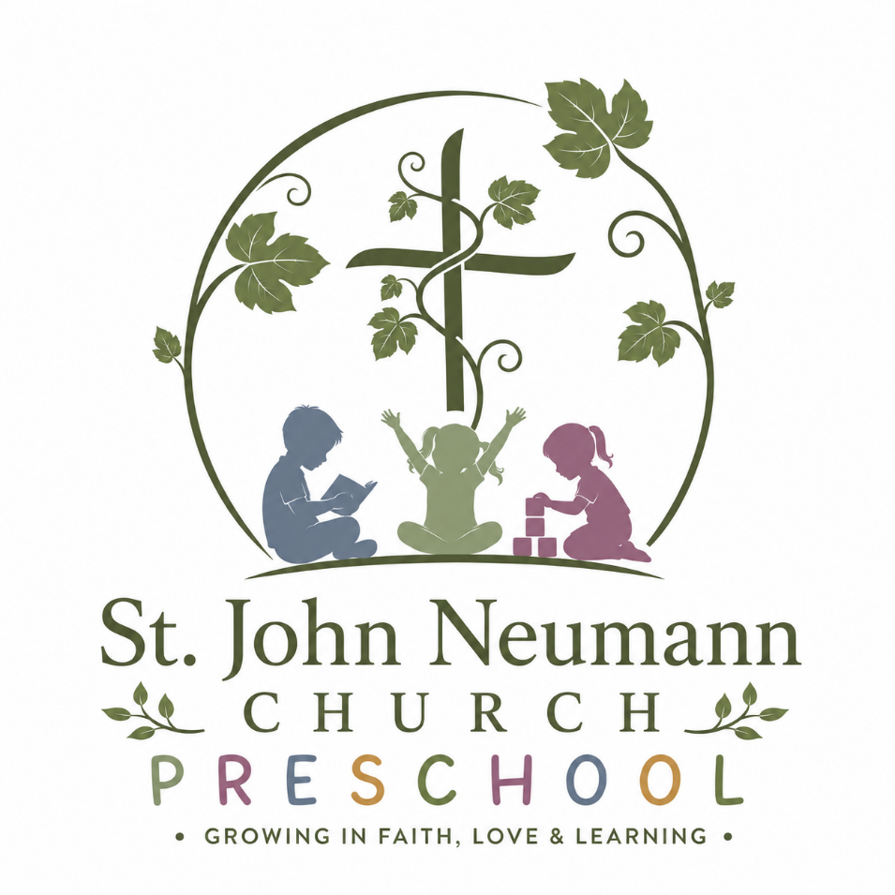

Family Handbook
2026-2027 School Year

801 Tom Smith Road
Lilburn, GA 20047
Wendy.guillory@sjnlilburn.com

St. John Neumann Church Preschool Family Handbook
Table of Contents

Letter from the Director | 4
Letter from the Pastor | 5
OUR SCHOOL AND STAFF | 6
Mission Statement and Philosophy | 6
Exemption from Licensure | 7
Office Hours and Contact Information | 7
FEES AND SERVICES | 8-11
Curriculum | 8
Our Daily Preschool Routine | 8
Registration and Enrollment | 9
Tuition | 9
Activity Fee | 10
Late Payment Fee | 10
Returned Check Fee | 10
Late Pick-Up Fee | 11
Calendar | 11
GENERAL POLICIES AND PROCEDURES | 12-18
Attendance | 12
Absences | 12
Withdrawal | 12
Early Arrival | 12
Late Arrival | 12
Early Pick Up | 13
Communication and Correspondence | 13
Social Media | 13
Green Cleaning Practices | 14
Classroom Supplies | 14
Diapers and Potty Training | 14
Preschool Attire | 14
Parent Involvement | 15
Outdoor Activity | 15
Substitute Teachers | 15
Toys from Home | 16
Birthdays | 16
Catholic and Private School Applications | 16
Conferences and Assessments | 16
Positive Guidance and Discipline | 17
Bullying | 17
Disenrollment | 17
General Carline Instructions | 18
HEALTH AND SAFETY POLICIES | 20-25
Archdiocesan Safe Environment Policy | 20
Child Abuse | 20
Visitors/ Guests / Security | 20
Release of Children | 20
Custodial Rights | 20
Emergency Contact Information | 21
Medication | 21
Immunizations | 21
Weather | 22
Other Safety and Emergency Concerns | 22
General Health Precautions | 22
Infectious Disease Policy  Biting | 23  24
Incidents/ Accidents/ Emergencies | 25
Allergies and Life-Threatening Medical Conditions | 25

Dear Parents,

Welcome to St. John Neumann Church Preschool. We are pleased to have your family at our preschool. We are very excited about our program, our staff and our wonderful church community. This handbook is meant to acquaint you with our preschool policies and procedures.

You have entrusted your child to our care during these upcoming months, and we consider this a responsibility and a privilege. We plan to help your child grow and develop spiritually, intellectually, physically, and socially. We strive to provide a warm, loving environment where your child can continue to discover God’s world.

The preschool program falls under the direction and guidance of the pastor of St. John Neumann Catholic Church. Our professional staff is responsible for planning and implementing a developmentally appropriate lesson plan based upon your child’s academic and social/emotional growth. To accomplish this, we make use of a play-based curriculum designed to teach how children learn best – through play! Our Catholic Faith and traditions are an important part of what we do. They are experienced by the children on a regular basis in everyday situations at school.

The staff of St. John Neumann Church Preschool is dedicated and talented. I am pleased to have the opportunity to direct this quality program that we continue to build. I am looking forward to getting to know both you and your child. Please contact me with any questions or concerns you may have regarding our program.

Sincerely,

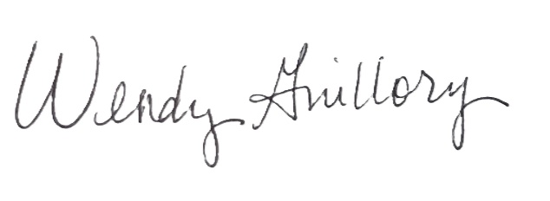

Wendy Guillory
Preschool Director

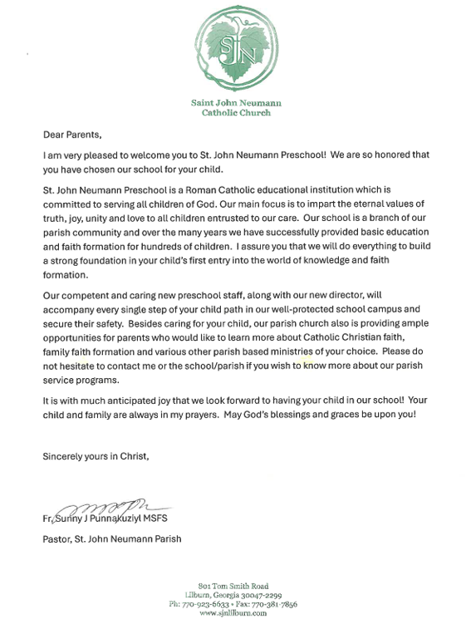

OUR SCHOOL AND STAFF

ST. JOHN NEUMANN CHURCH PRESCHOOL MISSION STATEMENT

The mission of St. John Neumann Church Preschool is to provide a safe, positive, and play centered Catholic Christian early learning environment; to promote each child’s cognitive, emotional, spiritual and physical growth; to support each child as they establish relationships with their peers; to offer positive early learning experiences and creative activities each day that invite children to explore; and to support parents as they raise their children with Godly values.

ST. JOHN NEUMANN CHURCH PRESCHOOL PHILOSOPHY

We believe that all children are unique and special individuals, wonderfully created by a loving God. We welcome each child as they are and gently invite them into relationship and learning through play. Our developmentally appropriate program is designed to build on the child’s learning and experiences at home as well as to expose them to learning in group situations. Through our play-based curriculum, we encourage school readiness and life-long learning.

It may look like play, but we are learning to:

- work and play together
- respect the rights of others
- express ourselves creatively
- develop self-control
- grow from dependence to independence
- listen to directions and follow them
- develop good work habits
- clean up after work time
- participate in group activities
- enjoy using a variety of materials and medium/media
- share toys, equipment and experiences
- develop an interest in the world around us
- improve motor coordination
- develop new interests and extend old ones
- learn about God’s love for us
- be happy

EXEMPTION FROM LICENSURE

St John Neumann Church Preschool operates under the supervision of the Archdiocese of Atlanta, Office of Catholic Schools. The Office of Catholic Schools ensures that this program follows the prescribed guidelines for parish early childhood programs and the preschool receives two Quality Assurance visits each year. Our preschool is not licensed by the state and is not required to be licensed by the state.

OFFICE HOURS AND CONTACT INFORMATION

The hours of operation for St. John Neumann Church Preschool office are: 9 am to 2 pm, Monday-Friday during the school year. Summer hours vary.
- Direct Line to St. John Neumann Church Preschool is 470-508-9841. Messages left after 2:00 p.m. will not be checked until the following school day.
- The preschool director can be reached by email at wendy.guillory@sjnlilburn.com
- Information about St. John Neumann Church Preschool is also located on the church’s website at www.sjnlilburn.com/religious-education/sjn-preschool
- The main number for the church is 770-923-6633

FEES AND SERVICES

OUR CURRICULUM

St. John Neumann Church Preschool implements a play-based curriculum. Preschool teachers provide a carefully curated learning environment where children are able to explore academics naturally through free choice centers, games and invitations to play. Student progress is monitored by their participation in hands-on activities and observational assessments rather than by worksheets and drills. This means that our skilled teachers know that play is an integral part of young children’s lives and that young children are deeply curious and learn a great deal through self-directed exploration. Being able to play, both alone and with others enhances children’s physical, social/emotional, and creative growth. Play is also critical to a child’s cognitive development and therefore is useful in supporting the development of science, math, language and literacy skills. Part of our day consists of free play so that children get to choose from a variety of planned and prepared activities that they can engage in with little direction from teachers. A smaller part of our day is spent in large group settings where all of the children meet together for group games, music, movement, stories, discussions and mini-lessons. Small groups are used so that children are engaged in activities that require more individualized attention. Outside time is an integral part of our learning day. In addition, our days are full of opportunities to know, love and serve our Lord. In age-appropriate and lively ways, the children are taught that God loves them, wants them to be happy and puts adults in their lives to help take care of them. Praying with the children, as well as teaching them Bible stories, fruits of the Holy Spirit, and more are a regular part of our day.

OUR DAILY PRESCHOOL ROUTINE

Children do well when activities and schedules are consistent. A routine will be followed each day to provide a sense of security. Because we also cherish “teachable moments”, the schedule is flexible.

- ARRIVAL: Children will go directly to their classrooms when they arrive at school in the morning. Teachers will remain in the classrooms at this time. This time of day is an integral part of learning. The transition between home and school sets the tone for the rest of the day. The children learn some school routines related to caring for their belongings, and the classroom is set up for centers with many choices for the child to choose from: puzzles, books, play dough, blocks, manipulatives, art, housekeeping, etc.

- GROUP TIME: Also known as Circle Time - One or two group times a day are used to teach curriculum, practice a skill, read stories or learn and recite songs and finger plays. Other group times include community helper visits, mystery reader and snack/cooking times.

- OUTDOOR PLAY: Children have highly supervised but usually unstructured playtime. They learn to share, take turns, and follow the safety rules playing on the outside equipment. Alternate activities are planned during inclement weather. Inclement weather is defined by preschool staff as rain (or previous rain keeping the playground very wet), temperatures below freezing or above 90 degrees. For these extreme temperature days, we may still try to get a few minutes of fresh air but will use caution (taking cold water with us for hot days or bundling up in coats and gloves for cold days).

- CLEAN UP: There is a place for everything, and the children learn the importance of keeping things clean and returned to the proper place. Everyone will participate in cleaning up. It teaches the child to move from one activity to another. We label our containers and shelves with shapes and pictures, so children learn to match, classify and count while cleaning.

- LUNCH TIME: Parents will need to send in a healthy lunch with their child each class day that their child attends preschool. The preschool reserves the right to declare a particular classroom “nut free” if a child in that class has a severe allergy. Parents will be notified if this is the case.

Please note: The following foods can be choking hazards and should not be given to children younger than 4 years of age unless it is completely chopped. Round, firm foods are common choking dangers. When infants and young children don’t grind or chew their food well, they may attempt to swallow it whole.

Chunks of peanut butter Nuts Popcorn
Chunks of meat or cheese Whole grapes Raw carrots
Hard or sticky candy Hot dogs

REGISTRATION AND ENROLLMENT

Preschool is for all children who are 2 to 4 years of age by September 1st of the current school year.

Registration for the upcoming school year will begin in mid-January of each year. The child’s age as of Sept. 1 will determine his/her class placement. A $225.00 registration fee is required, and this is non-refundable as long as your child is offered placement.

TUITION

Tuition at St. John Neumann Church Preschool is based on the cost to run our program for the entire school year and is based on the number of days of per week a child’s class is scheduled to meet. Our monthly tuition schedule is as follows:

Two-year-olds  2 days per week $220 per month | Two-year-olds  3 days per week $240 per month | Two-year-olds  4 days per week $280 per month | Three-year-olds  3 days per week $240 per month
Three-year-olds  4 days per week $255 per month | Three-year-olds  5 days per week $270 per month | Four-year-olds  4 days per week $270 per month | Four-year-olds  5 days per week $290 per month

Tuition will be paid online, and parents will have access to financial statements through the Brightwheel Parent Portal. Alternatively, cash or check may be presented by parents to the preschool office staff.

Tuition will not be adjusted for holidays, inclement weather or absences (including family travel). For ease of accounting, the tuition rates were calculated based on the total number of days of class and divided among the school months from September through May.

ACTIVITY FEE

An activity fee of varying amounts (depending on registration choice) per child is due and payable to the preschool by July 15. This fee covers costs associated with school-wide functions offered to our families.

LATE PAYMENT FEE

Tuition is due and payable on or before the FIRST DAY OF THE MONTH. If tuition is not paid by the 5th of each month, a $25 late fee will be added to your account. If tuition is not paid by the 10th of each month, an additional $50 late fee will be added to your account. If tuition is not paid by the 15th of each month, the director will notify parents that the child will be suspended and risk disenrollment from the program until your account is made current. Should you experience an unusual financial situation, please contact the Preschool Director to discuss possible payment plans.

RETURNED CHECK FEE and DECLINED CREDIT CARD FEE

If a check is returned by the bank for any reason, a $25.00 fee will be charged. If a credit or debit card payment is declined, a $15.00 fee will be charged.

LATE PICK-UP FEE

Dismissal for all classes is at 1:15. Parents who pick up their child(ren) at 1:25 or later without making prior arrangements will be subject to an initial $5.00 late fee per child with $1.00 per minute thereafter. This fee is imposed at the discretion of the director and emergency situations will, of course, be taken into consideration. If you are going to be delayed, please call the preschool office, and let us know. Communicating that you will be late to pick up your child should never be done through email. The director reserves the right to dismiss from the program any child that is continually picked up late.

Please note: The preschool staff attend a monthly staff development meeting that is usually held on the next-to-last Tuesday of every month. We will dismiss the children at 12:15 on days when the meetings are held. Please check your monthly calendar to make note of these days. Late fees will apply for late pick up.

CALENDAR
In general, St. John Neumann Church Preschool follows the calendar set by Gwinnett County Public Schools. There are some exceptions, including some religious holidays, GCPS early release days, GCPS digital learning days/teacher workdays. Preschool parents will have access to both yearly and monthly calendars well in advance so that all are aware of the calendar. St. John Neumann Church Preschool is required to have a staff meeting once per month, and this will be an early release day for preschool students. This will also be indicated on monthly calendars.

GENERAL POLICIES AND PROCEDURES

ATTENDANCE

Attendance in preschool is not required or penalized as in the public and private elementary schools. We do believe that it is important to teach children good habits about regular attendance in school.

ABSENCES

Annual tuition (divided into equal payments throughout the school year) already considers school holidays, teacher workdays, and weather-related closings. Tuition will not be prorated for these days or for days missed due to illness, vacation or other occasions. We do not offer make-up days. If your child’s absence is in any way related to illness, please contact the preschool office to discuss the nature of the illness as soon as possible.

WITHDRAWAL

When withdrawing your child from St. John Neumann Preschool, 30 days written notice is required so that we may have time to fill the spot with another child. This policy is standard in the industry and will be regularly enforced. If 30 days’ notice is not possible, tuition will be charged to your account. All tuition is non-refundable.

EARLY ARRIVAL

Our school day begins at 9:30 with our morning car line. Children cannot be dropped off before this time. Teachers are preparing for the day and cannot adequately supervise children at this time.

LATE ARRIVAL

When a child is late to school, he misses out on important early morning activities and routines. Late arrivals are also disruptive to the class and to the office staff. Please make every effort to arrive on time and to drop your child off from the carline.
If you arrive after carline has ended, please park in the parking lot and walk your child to the main Preschool entry (the door facing the playground). Ring the bell to alert the preschool office that you have arrived, and we will come to the door to get your child and have you sign your child in.

EARLY PICKUP

If you need to pick your child up from school before the end of our school day, please make arrangements to do this before 1:00. Send a note to your child’s teacher, message us in Brightwheel or email the preschool office to let us know who is picking your child up and the time they will be arriving. When you arrive early, park your car in the parking lot, and walk to the main Preschool entry (the door facing the playground). Ring the bell to alert the preschool office that you have arrived. A photo ID will be requested if we do not recognize you or your designated pick-up person.

FOR REGULAR ARRIVAL AND DISMISSAL PROCEDURES, PLEASE SEE GENERAL CARPOOL INSTRUCTIONS ON PAGE 18.

COMMUNICATION AND CORRESPONDENCE

In general, emails and phone calls will go through the preschool office. Teachers will not give their personal email or telephone number to parents.

Electronic Communication:
- Weekly electronic newsletters will be sent via Brightwheel from the teacher
- Occasionally notices that pertain to the entire school will be emailed from the Director or sent via Brightwheel. Paper copies are available upon request.
- If you have any questions or concerns, please call or email the Director.
- If you have a concern about your child, please call the preschool office to set up a conference to discuss your concerns.

Hard copy Communication:
• Please check your child’s folder for notes from the teacher each day after school.
• Please place any correspondence to teachers or to the office in your child’s folder.

SOCIAL MEDIA

St. John Neumann Church Preschool follows the guidelines outlined by the Archdiocese of Atlanta for responsible use of all social media, including email, Facebook, Twitter, and web sites. Please be sensitive about posting pictures of preschool children other than your own on any personal social sites. Refer to the Archdiocese of Atlanta website to review the complete Social Media Policy – www.archatl.com

GREEN CLEANING PRACTICES

According to the United States Environmental Protection Agency and the American Academy of Pediatrics, chemicals that are commonly used for cleaning, sanitizing and disinfecting can affect human health, especially the health of children. St. John Neumann Church Preschool will use cleaning, sanitizing and disinfecting products that are less hazardous to protect our children and staff. Parents will be provided with a list of approved products at orientation. These products will be third-party certified products that will help to minimize exposure to toxic chemicals found in popular products.

CLASSROOM SUPPLIES

We ask that your child have a backpack large enough to carry a pocket folder, and a lunch box. There are other items that teachers may ask for, such as tissues, baby wipes, etc. You will be notified by your child’s classroom teacher if these things are requested.

DIAPERS AND POTTY TRAINING

St. John Neumann Church Preschool does not have a potty-training requirement for the two-year-old or the three-year-old classes. If your child is not yet working on potty training, you will need to provide diapers and wipes for each day of preschool. Please note that due to storage issues, we are unable to store large boxes of diapers for your child. When children are beginning to work on potty training at home, we ask you to let the teacher know, and be sure to send extra clothes in case of accidents. Four-year-old Pre-K children are expected to be completely potty trained with very few accidents.

PRESCHOOL ATTIRE
Because school is a place for exploring and learning about many things, we request that you dress your child in clothing that is suitable for school.
- Suitable clothing consists of play clothes that promote freedom of movement and freedom from worry about spills, splatters and dirt.
- Clothing should be simple enough for your child to get in and out of easily, with little or no help.
- Belts are not permitted because they can hinder your child’s ability to use the bathroom quickly and can lead to embarrassing accidents.
- Clothing with fasteners that children can handle themselves builds confidence.
- Gross motor (big muscle) skills are an integral part of the preschool day. Therefore, all students MUST wear comfortable, well-fitting shoes to school. Tennis shoes and socks are most appropriate as feet are well protected and provided proper support for outdoor activities. Shoes should fit well enough to not slip off when the child is running. No boots, flip flops, shoes that are open in the back.
- Each child is required to always have an extra set of clothes at preschool. These extra clothes should be sent to school in a large zip-loc bag that is clearly labeled with your child’s name. Include socks and underwear. If these extra clothes are used, please replace them the following day.

PARENT INVOLVEMENT

The most important thing you can do to be involved with your child’s school experience is to take time to listen to your child as they relate the happenings of the day at preschool. Place their artwork on exhibit and let them tell you about it. Let them lead in prayer at mealtime. The more the preschool experience is shared with the family, the more meaningful the experience will become.

Parents are always welcome to visit and observe the classroom activities. Please call the preschool office so that a convenient time for you and the teacher can be scheduled. The continuity of the classroom needs to be maintained for the benefit of all the children in the classroom.

We welcome and encourage the participation of parents at our preschool. If you are willing and available, we have a number of activities for you to be involved with your child’s education.

- Teacher Appreciation Committee - these parents organize quarterly meals to show their appreciation for the preschool staff
- There may be additional opportunities discussed by individual teachers.

OUTDOOR ACTIVITY

Weather permitting, children in our preschool play outside every day as a regular part of our curriculum. All children participate in this activity. If you feel your child should not be outdoors, please keep your child at home. It is not possible for your child to remain indoors when the class and teachers go outside.

SUBSTITUTE TEACHERS

If a teacher is unable to come to school, a substitute teacher will be called to fill in. These teachers are employees of the Archdiocese of Atlanta and of St. John Neuman Church, and, as such, are screened and background checked.

TOYS FROM HOME

Children should not bring personal toys to school. Children’s books or items pertaining to the curriculum are always welcome.

BIRTHDAYS

Birthdays are an important day for young children! We invite you to send a special birthday treat that will be served as a snack. Please contact your child’s teacher in advance to arrange the treat. Parents may attend this celebration, if you would like to do so. No additional guests or hired entertainers will be permitted. Please do not bring favors or “goodie bags” for the children to take home. Balloons may pose a choking hazard and are not appropriate at a preschool party. If you are having a home party for your child, please do not bring invitations into class unless all the children in the class are invited.

CATHOLIC AND PRIVATE SCHOOL APPLICATIONS

St. John Neumann Church Preschool staff are happy to complete any recommendation forms necessary for the application process for a Catholic or other private school. Please allow 10 days for the completion of forms. Attendance at St. John Neumann Church Preschool does not in any way ensure admittance to any Catholic or private school.

CONFERENCES AND ASSESSMENTS

Every child in our program will receive a written report weekly for the first six weeks of school indicating the child’s progress toward transitioning into the school setting. This report will include such things as how well the child is following classroom rules, how well the child is learning the classroom routine, care for classroom materials and more.

Children in a Two-Year-Old Class will receive a monthly report starting in October indicating the child’s progress toward classroom learning standards. Children in a Three-Year-Old Class will receive an assessment report three times throughout the school year (the end of October, January and April). Children in a Four-Year-Old Class will receive an assessment report at the end of October and end of March. A parent/teacher conference may be scheduled at any time during the school year. In March, the 4-year-olds will have a parent/teacher conference to discuss kindergarten readiness. The conferences may not be recorded or posted on any social media.

POSITIVE GUIDANCE AND DISCIPLINE

Limits for classroom behavior that are clear, consistent, fair and age appropriate will be set in all classrooms. The limits are based on the principles of keeping every child safe, preventing injuries, and showing respect for others and the property of others. Staff members will try to anticipate and eliminate inappropriate or unsafe behavior by redirecting children to a more acceptable activity or behavior. Staff will model skills that help children resolve problems. Staff will acknowledge children’s feelings and frustrations and respond with respect and guide children to resolve conflicts. Staff will patiently remind children of rules and use mistakes as learning opportunities. If there is an ongoing concern, staff will contact the child’s parents for a meeting.

The director reserves the right to disenroll any child if severe or repeated discipline problems persist or if the child seems unable to participate in our preschool setting.

BULLYING

Bullying is defined as repeated, aggressive behavior intended to make another child feel inferior. Any incidents of bullying will be dealt with in a timely and appropriate manner. Bullying at parish preschools will not be tolerated.

DISENROLLMENT

Although rare, a situation may arise in which it becomes evident that the needs of a child cannot be met effectively by our program. Some possibilities include: behavioral issues that involve a child causing harm, whether intentional or not, to other children and/or a lack of response from parents to our requests regarding their child. Additionally, parent behavior toward staff and other families in the preschool can be considered a cause for disenrollment. A decision to disenroll a child will only happen after our preschool staff and church administration feels every option has been explored. Our director will assess each disenrollment not only with regard to the individual child’s needs, but also the needs of all the children served. The parent will be a central figure in the discussions regarding this issue, but the decision to disenroll a child is left to the discretion of the director and church administration.

GENERAL CAR LINE INSTRUCTIONS

Our car line system is, by far, the safest way for children to enter and leave the building. Please help us keep everyone safe by adhering to our car line system. Please be patient, especially at the beginning of the school year when the children are getting used to the process. Our goal is to make this system as efficient as possible.

- For the safety of Preschool staff and students, we ask that there is NO CELL PHONE USE WHEN THE CAR LINE IS MOVING
- Please make every effort to be on time for drop off and pick up.
- When arriving to school in the morning, please stay in your car and form a line from the car line entry door (door facing parking lot), through the parking lot as instructed on page 19. Move forward in line only when the cars in front of you begin to move forward also. Do not pass or try to maneuver around another car in line.
- Your child will be removed from the car by a staff member and brought inside the building.
- If your child cries when leaving the car, please know that in most instances, the crying stops very quickly after getting into the building. If you are concerned about your child crying when being dropped off at school, please feel free to call the office after carline has finished and we can give you an update on your child’s emotions and activities.

- When arriving to school in the afternoon for dismissal, please stay in your car and form a line from the car line entry door (door facing parking lot). Please follow directions from any staff member in the parking lot.
- You will be given a car tag that indicates your child’s name and class. Please display this in the front window of your car, visible to staff.
- Please remain in your car.
- A preschool staff member will escort your child to your car, help them get inside and close the door.
- BY LAW all children are required to be buckled in a CAR SEAT. We ask that you pull forward in the parking lot to a parking space to buckle your child’s car seat. Preschool staff will not buckle children into car seats for you. For more information on Georgia car seat laws please see https://www.gahighwaysafety.org/child-passenger-safety/

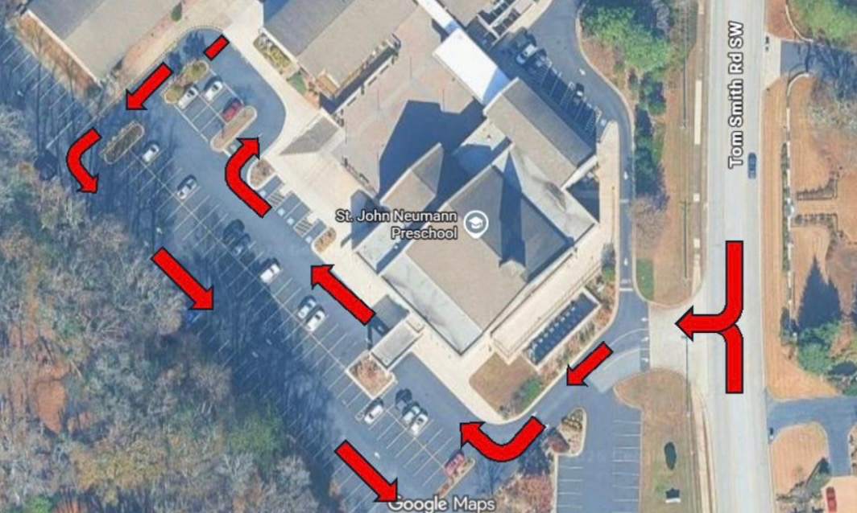
HEALTH AND SAFETY POLICIES

ARCHDIOCESAN SAFE ENVIRONMENT TRAINING

All staff members, substitute teachers and volunteers are required to complete this training, known as VIRTUS. Information will be provided to parents who wish to register for this class.

CHILD ABUSE
All Preschool staff must comply with Georgia law requiring schools and individuals to report all suspected cases of child abuse / neglect / deprivation to the Department of Family and Child Services, our Pastor and the Director of Parish Early Childhood Programs at the Archdiocese of Atlanta.

VISITORS/ GUESTS/ SECURITY

Our preschool entrances remain locked while children are in the building. Visitors/parents/guests to the preschool must use the main entrance (door facing playground). There is a doorbell to alert preschool office of your arrival. All visitors will be required to sign in the Visitors’ Log.

RELEASE OF CHILDREN

Children will only be released to parents or those on the Emergency Contact List. If your child is to be released to someone not on this list, we must have a note indicating this, signed and dated by the parent. In the event that the decision to have someone else pick up your child was a last-minute decision, please call the preschool office. Email is NOT considered to be an effective means of communication in this matter. Preschool staff will ask to see identification if we do not recognize the person picking up a child. If a child carpools with another child on a regular basis, please inform the director’s office in writing and including those names on your emergency contact sheet. We will be happy to supply additional carpool signs for each child.

CUSTODIAL RIGHTS

We may not deny a parent access to his or her child without legal documentation. Therefore, any legal document which restricts a parent’s access to a child must be presented and on file with the preschool.

EMERGENCY CONTACT INFORMATION
It is the parent’s responsibility to keep all emergency contact information up to date and to notify the Preschool Director of changes. It is highly recommended to have multiple emergency contact names and numbers in case we are unable to reach parents. When your child is in our care, PLEASE MAKE SURE YOUR CELL PHONE RINGER IS ON WITH THE VOLUME TURNED UP. We need to be able to contact you as soon as possible if your child becomes ill or injured during the preschool day. If we are unable to reach you or anyone on your child’s emergency contact list and we feel that immediate attention by a medical professional is warranted, we will call 911 and you are responsible for any cost incurred.

MEDICATION

Preschool staff is unable to dispense medication to any student with the exception of medication needed for a life-threatening condition, such as allergic reactions or asthma. Proper medical documentation and forms must be kept up to date by the parent and copies will be on file in the Preschool Office and the classroom.

If your child is receiving any medication at home that may alter his behavior, such as decongestants, laxatives, breathing treatments, etc., please let your child’s teacher know.

IMMUNIZATIONS

All children attending Catholic parish preschools must meet Georgia state standards for immunization. The Office of Catholic Schools requires Georgia Immunization Form 3231 to be current and on file before children enter the preschool program.
- Religious Exemption
Catholic doctrine does not support an exemption from immunization based upon a matter of conscience/religious exemption. For this reason, religious exemptions are not accepted in parish preschool programs.
- Medical Exemption
The medical exemption is applicable when a child has a long-term condition that contraindicates immunization. Parents requesting exemption from immunization must provide a detailed explanation of the child’s condition as documented by his pediatrician. The Archdiocese of Atlanta reserves the right to obtain a second opinion. The medical exemption must be renewed annually.

- Delayed/Alternative Vaccination Schedules
These delayed schedules are not accepted in Archdiocese of Atlanta parish preschools.

- Epidemic, Outbreak, Exposure
In the event of a contagious disease epidemic, outbreak or exposure, children with medical exemptions will be required to remain at home until their health and safety is no longer at risk.

WEATHER

In the event of inclement weather, the Preschool Director will inform parents of any decisions to close or delay the opening of preschool. These decisions are often made at the last minute and it is important for parents to be aware. Decisions will be communicated to parents via Brightwheel message. Due to Gwinnett County Public Schools’ use of digital learning days during inclement weather and at other times, we do not strictly follow the public school system regarding closures.

OTHER SAFETY AND EMERGENCY CONCERNS

Attendance is taken daily and submitted to the Preschool office. Teachers take headcounts throughout the school day and after any transition to a new activity or location to ensure the safety of the children. Fire Drills will be held monthly. Severe Weather Drills will be held quarterly. Lockdown Drills will be held twice a year. In the event of a necessary evacuation of the Preschool/Church building, teachers will escort their classes to the far side of the parking lot. Parents will be notified through emergency contact phone numbers. Children will be dismissed to a parent or other parent- authorized adult.

GENERAL HEALTH PRECAUTIONS

Any child with a fever, sore throat, an acute cold or cough, diarrhea or vomiting will not be allowed to attend class. A child must be fever free without fever-reducing medication for 24 hours before returning to preschool. If an antibiotic has been prescribed by your doctor for treatment of an illness, the child must have had two doses of medication before being allowed to return to class. Please be considerate of other children and adults in the program by keeping your sick child at home until they are well. The director has the right to send home any child who is sent to preschool sick. If your child comes down with a communicable disease such as COVID-19, Hand Food and Mouth Disease, chicken pox, pink eye or the flu, you are required to notify the director as soon as possible to discuss quarantine procedures.

INFECTIOUS DISEASE POLICY

The primary responsibility for the prevention and control of infectious diseases lies with individuals, families, and public health authorities. Schools are not responsible for providing expert infectious disease advice or treatment for students; this is the role of medical practitioners and health authorities.

Attendance at any school may be denied to any student reasonably suspected of or diagnosed with a contagious or infectious disease that could make the child’s attendance harmful to the welfare of all other students, faculty, and staff.
Schools reserve the right to require a statement from the student’s primary care physician authorizing the student’s return to school. Schools will respect all students’ privacy. Parents of other children attending the school may be notified that their child has been exposed to a communicable or infectious disease in a manner that avoids identifying the student with the disease to the maximum extent appropriate in each particular circumstance. Please note that specific to Hand, Foot and Mouth Disease, children may return to school when they are blister-free.
During periods of infectious disease, some operational procedures and events may be added, modified and/or cancelled including but not limited to:
• Prevention techniques – hand washing education, coughing and sneezing education; hand sanitizers in classrooms; sanitizing wipes in classrooms for computers, desks, common areas, etc.; tissues in all rooms; sanitation procedures; and if appropriate, the mandated use of facial masks along with social distancing.
• Preparedness – Schools will comply with CDC, State Department of Health guidelines, and directives from the Office of Catholic Schools.
• Response – Schools will follow the Office of Catholic Schools policy for school closures (Policy 5285) and directives from State and Local (County and Municipal) jurisdictions. The Office of Catholic Schools will provide a written Reopening of Schools Plan specific to the infectious or communicable disease present.
• Recovery – Schools will publish a return to school procedure in accordance with directives from the Office of Catholic Schools which aligns to the Reopening of Schools Plan approved by the Superintendent of Schools.
BITING
Biting is a normal, developmentally appropriate (although not morally accepted) behavior for young children. It is especially apparent during the ages of 9-30 months. Generally, children over the age of 3 have developed more appropriate ways to communicate. Experts in the field of child development report that biting occurs chiefly as a result of a child’s incapacity to communicate. Children may bite out of frustration. They may bite because of language barriers. They may even bite because of the frustrations that come with teething. While biting during the toddler years is developmentally appropriate, we know that biting hurts and is upsetting to parents, students and teachers when it occurs. The goal of our policy is to replace the child’s undesirable behavior with more effective ways of communicating and to also ensure the health and safety of everyone in our program. The following is a plan of our preemptive strategies.

- If it is determined that a child is teething, positive teething activities will be provided to comfort and soothe their gums.
- If a bite takes place the child who bites is told, “Ouch, that hurt ______” in a firm but gentle voice. The teacher then administers care to the child who has been bitten. The child who bit may be asked to help and shown “gentle touch”. Ice or a cold pack is administered. If the skin is broken, the wound is washed with soap and water and a Band-Aid is applied.
- If a child bites out of frustration or anger, teachers will redirect their behavior to something that is appropriate to bite – like teething rings. We will encourage the use of language to express wants and needs.
- Both the parents of the child who bit and the child who received a bite will be notified in writing. To protect the privacy of our families, parents of a child who was bitten will not be given the name of the biter.
- If a child bites frequently, staff will utilize a more intensive approach which involves carefully observing the child to determine precipitating events and maintaining a log to help track the behavior. This log includes documenting time, activity occurring, child bitten and body part bitten. Staff will establish “shadowing” of the child who is biting, possibly dividing the group into small sub-groups to decrease noise and activity levels. If possible, additional staff will be in the room during high activity times.
- Conferences with parents may also be utilized to discuss the child’s actions at home, search for outside resources, etc.

If the biting is a symptom of a more serious situation (such as special needs that our staff cannot provide for) and the above procedures still do not resolve biting, the child may be asked to leave the program.

INCIDENTS / ACCIDENTS / EMERGENCIES

Parents will be notified via Brightwheel of any minor injury or incident that causes a child discomfort.

If a more serious injury occurs, parents will be contacted immediately. If outside medical treatment is required, a written report will be sent to the St. John Neumann Church Business Manager and the Director of Parish Early Childhood Programs at the Archdiocese of Atlanta. A copy of this report will be placed in the child’s file.

In the event of a life-threatening emergency, we will immediately call 911. Parents will then be notified and informed of the hospital location used by the ambulance service. A written report will be filed with St. John Neumann Administration, the Director of Parish Early Childhood Programs, and the child’s file. You are responsible for any cost incurred.

ALLERGIES AND LIFE-THREATENING MEDICAL CONDITIONS

Neither our Preschool nor our Church Facility is completely allergen free. We cannot guarantee that every person, their belongings, or surfaces are free of cross contaminates.

- If your child has a severe medical condition, we will ask that you set up a conference time prior to your child’s first day of school to discuss your child’s needs with Preschool staff
- Prior to the start of school, you will be asked to complete our Allergy/Medical Action Plan describing details of your child’s condition as well as appropriate treatment recommended and signed by your doctor. In addition, an Authorization to Give Medication form must be signed by the doctor and kept in the child’s file.
- If a child requires an Epi-pen, or similar product, 2 must be provided.
- If any food allergy exists, you will be asked to supply us with a few “safe foods/treats” to be used when other snacks or treats are sent in by other parents.
- Other families will be notified during the first week of school if there is a food allergy present in the classroom and what actions are required by those other parents. In addition, an Allergy Alert sign will be posted on the door of the child’s classroom.
- If a child in a class has a food allergy that requires an Epi-pen as treatment, that classroom only will be designated as free from that allergen.
- Expired medications must be disposed of by parents and a replacement provided.
- Any medical device or medication that is required to be with the child at school must be provided to preschool staff on a daily basis or left at preschool for our use.
- If the preschool has an allergy on record for your child and your child has completed exposure therapy and is considered no longer allergic, a note from the child’s doctor must be submitted to the preschool office indicating this change.

St. John Neumann Church Preschool reserves the right to amend this handbook at any time and parents will be notified by email about changes. If you have any questions, comments or concerns please contact the preschool office. Thank you for sharing your little ones with us. We look forward to a wonderful school year!

